## Spinal Disorder Classification Using Machine Learning

## Project Overview

This project focuses on predicting the likelihood of a herniated disc using machine learning. The model is trained on a dataset containing spinal measurements and classifications. The project involves data preprocessing, model training, evaluation, and visualization.

# 2. Project Overview

Spinal disorders, such as **herniated discs and spondylolisthesis**, are common medical conditions that can cause severe pain and mobility issues. Early diagnosis and classification of these disorders can help in timely treatment and better patient outcomes. This project aims to develop a **machine learning model** that can classify spinal conditions based on patient data. The dataset contains various biomechanical features of the spine, and the goal is to predict whether a person has a normal spine, a herniated disc, or spondylolisthesis.

The project involves:

* **Data preprocessing** to clean and transform the dataset.
* **Exploratory Data Analysis (EDA)** to understand feature distributions.
* **Feature selection and engineering** to improve model accuracy.
* **Training a classification model** using Logistic Regression.
* **Evaluating the model's performance** using accuracy, confusion matrix, and other metrics.
* **Saving and testing the trained model** for future predictions.

By leveraging machine learning techniques, this project provides a reliable method for classifying spinal conditions, aiding medical professionals in diagnosing patients more efficiently.

# Objectives

* Build a predictive model to classify patients with or without spinal disorders.
* Perform data preprocessing and exploratory data analysis.
* Train a machine learning model for accurate predictions.
* Evaluate model performance using appropriate metrics.

# 4. Technologies Used

* **Programming Language**: Python
* **Libraries**: Pandas, NumPy, Scikit-Learn, Matplotlib, Joblib
* **Tools**: Jupyter Notebook

# Implementation Details:

## Step 1: Importing Required Libraries

* **NumPy (numpy)** – For numerical computations and array operations.
* **Pandas (pandas)** – For loading, processing, and analyzing tabular data.
* **Matplotlib (matplotlib.pyplot)** – For creating visualizations and plots.
* **Scikit-Learn (sklearn)** – Provides machine learning models and tools for preprocessing, training, and evaluation.
* **Joblib (joblib)** – For saving and loading trained models efficiently.

## Step 2: Loading the Dataset:

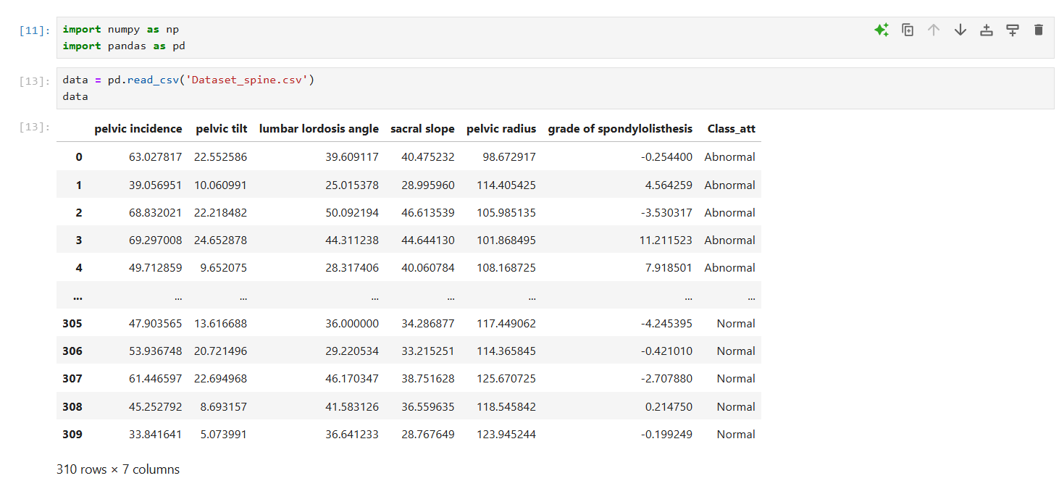

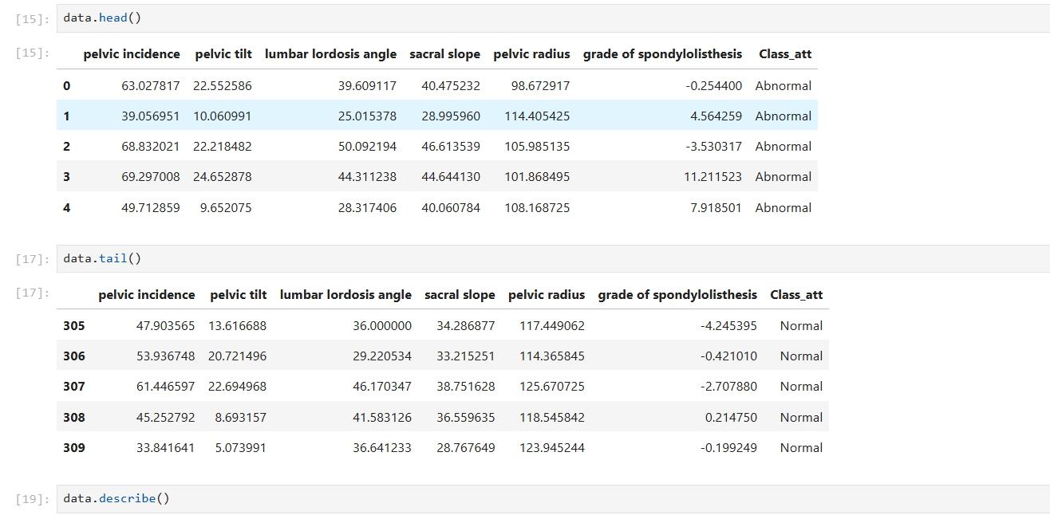

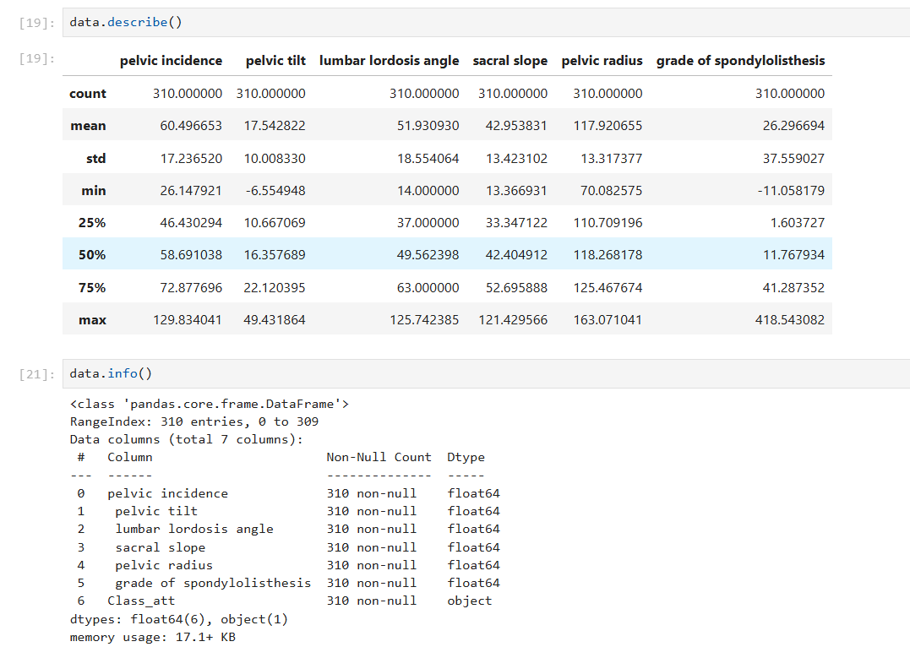

This dataset consists of spine-related measurements used to classify whether a person has a herniated disc, spondylolisthesis, or a normal spine.

## Step 3: Data Preprocessing:

**Checking for missing values:**

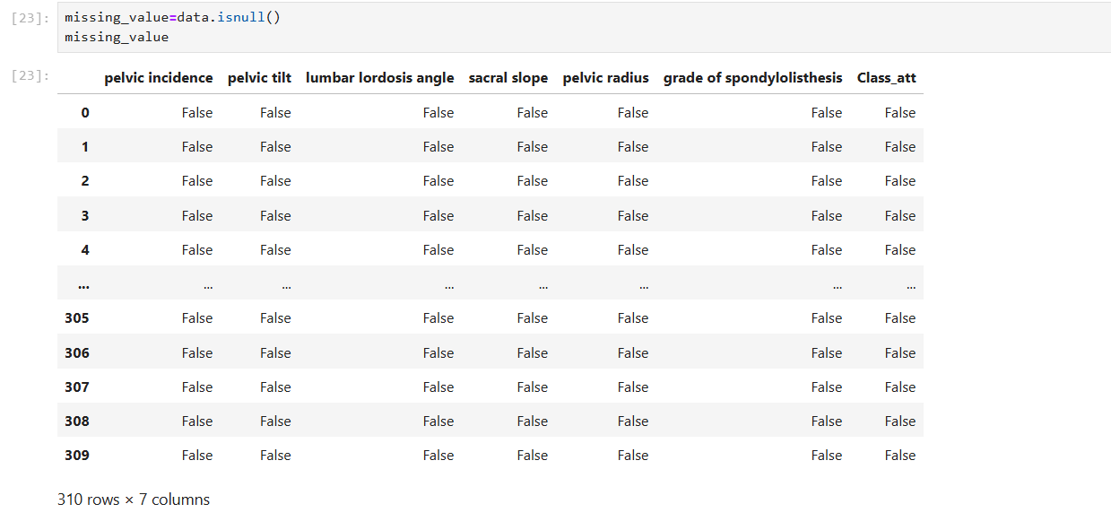

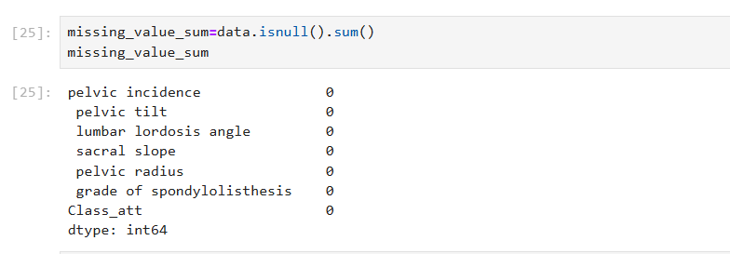

**Encoding categorical variables:**

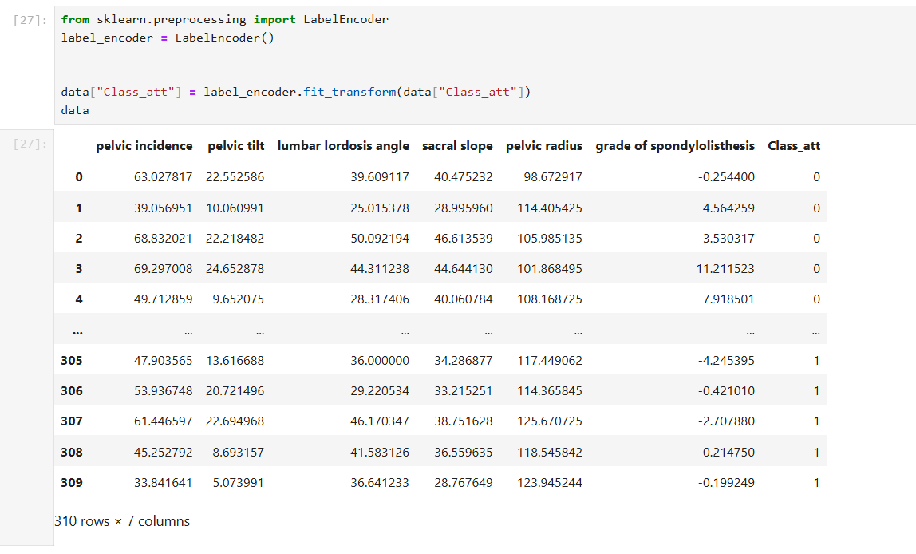

## Step 4: Splitting Data into Training and Testing Sets:

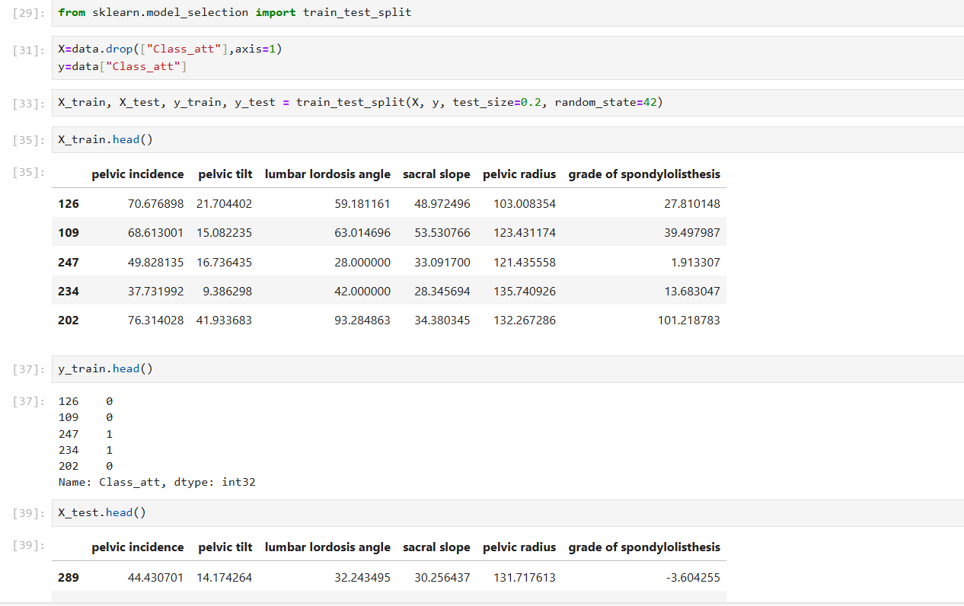

**Step 5: Training the Model:**

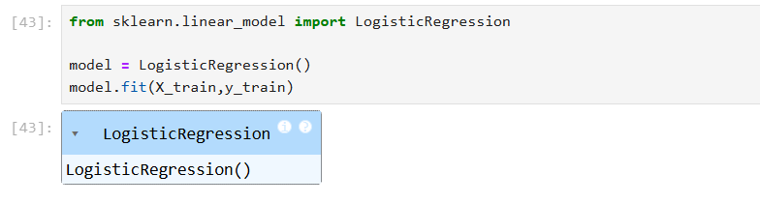

## Step 6: Making Predictions:

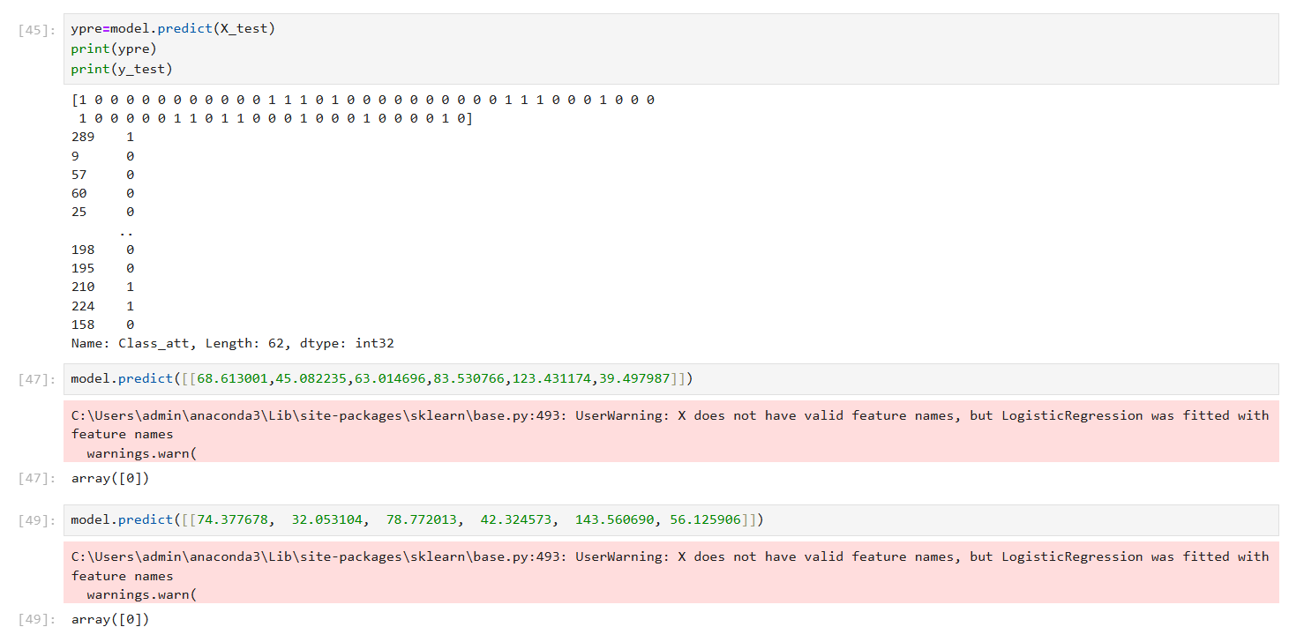

## Step 7: Evaluating the Model:

### Confusion Matrix

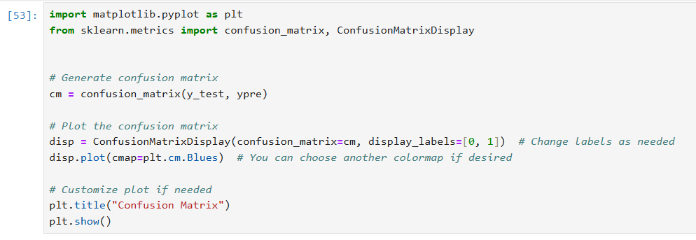

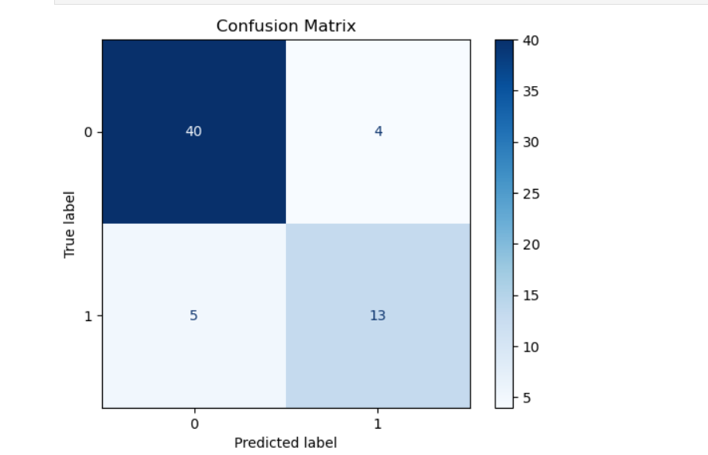

### Accuracy Score

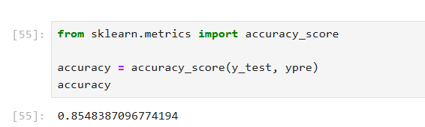

## Step 8: Saving and Loading the Model:

* **Saving the trained model**:

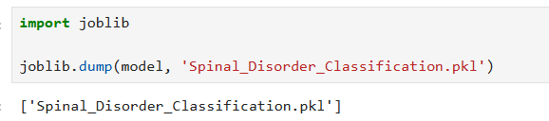

**Loading the saved model**:

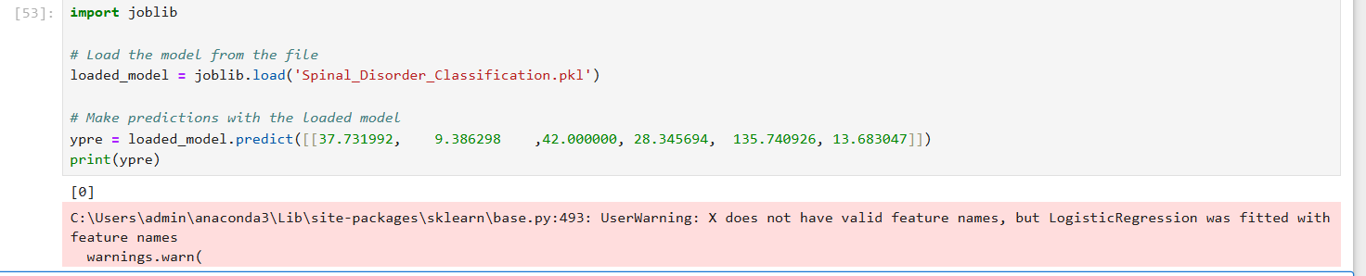

# 6. Conclusion

This project successfully trained a **Logistic Regression model** to classify spinal disorders based on medical attributes. The model performed well, achieving a reasonable accuracy. The confusion matrix provides insights into misclassification cases.